Assignment

Module 4:

OOP Concept

* Prepared by

Ishan Singh Lodhi

**Q. What is OOP? List OOP concepts?**

Ans. **Object Oriented Programming (OOP):**

* In order to remove some of the flaws of POP, OOP came into existence.
* OOP treats data as critical element in program development and does not allow it to flow freely around the system.
* It ties the data more closely to the function that operates on it.
* Object Oriented Programming allows decomposition of program into a

number of entities called objects and then builds data and function around these objects.

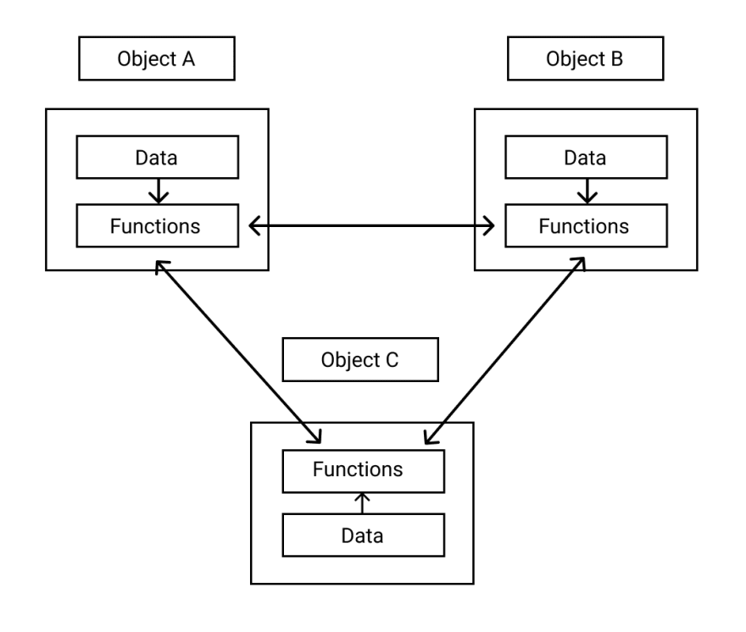

**Types of OOP:**

* Some of the basic concepts of object-oriented programming are:

1. Classes
2. Objects
3. Abstraction
4. Encapsulation
5. Inheritance
6. Polymorphism
7. Classes

* Classes contain data and functions bundled together under a unit. In other words, class is a collection of similar objects. When we define a class, it just creates template or Skelton. So, no memory is created when class is created. Memory is occupied only by object.
* E.g., Fruit is class of Apple

1. Objects

* Objects are an instance of class.
* In other words, classes act as a data type for objects.

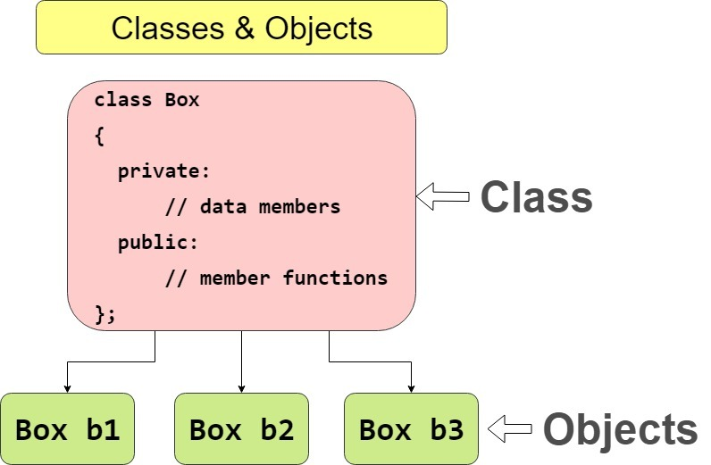

1. Abstraction

* Abstraction means displaying only essential information and hiding the details. Data abstraction refers to providing only essential information about the data to the outside world, hiding the background details or implementation.

1. Encapsulation

* In normal terms, Encapsulation is defined as wrapping up of data and information under a single unit.
* In Object-Oriented Programming, Encapsulation is defined as binding together the data and the functions that manipulate them.



1. Inheritance

* The capability of a class to derive properties and characteristics from another class is called Inheritance.
* Inheritance is one of the most important features of Object-Oriented Programing.
* Inheritance supports the concept of “reusability”, i.e. when we want to create a new class and there is already a class that includes some of the code that we want, we can derive our new class from the existing class. By doing this, we are reusing the fields and methods of the existing class.
* Types of Inheritance are:

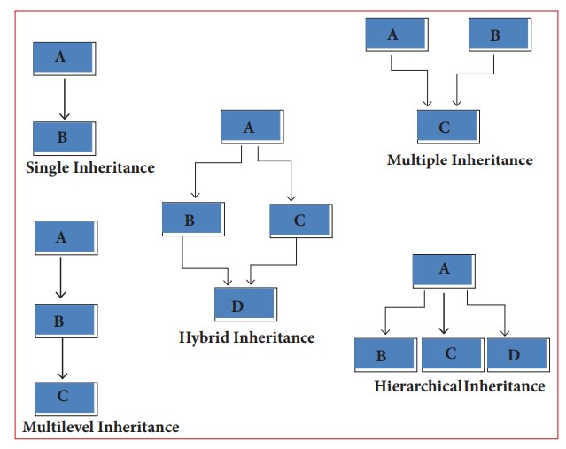

1. Polymorphism

* The word polymorphism means having many forms. In simple words, we can define polymorphism as the ability of a message to be displayed in more than one form.
* C++ supports operator overloading and function overloading.

**Q. What is the difference between OOP and POP?**

Ans. **Difference Between OOP and POP:**

